CUSTOMER CHURN PREDICTION IN TELECOM INDUSTRY
(Machine Learning Based Customer Retention System)
Methodology, Novelty and Key Contributions
Department of Computer Science and Engineering, TKR College of Engineering and Technology (Autonomous)
Batch A14 (CSE-A) · Academic year [ACADEMIC YEAR]
Table 1: Project team
S.No. | Student name | Roll number
1 | ANANTULA SAI NIKHILA SRAVANI | 23K91A0512
2 | AVULA ANUDEEP | 23K91A0518
3 | B SANDEEP | 24K915A0503
4 | DARAGANI VINOD KUMAR | 23K91A0558

Project guide: B. SRIKANTH, Assistant Professor, Department of CSE
Chapter and section numbers quoted in the text (for example Section 6.6 or Chapter 8) refer to the full project report, 17.Final Document. Figures and tables in this document are numbered from 1.

1. OVERVIEW OF THE METHODOLOGY
This document describes how the system works from end to end and what is new in it. Part 1 gives the pipeline, the data, the algorithms and the reasons they were chosen; Part 2 sets the work against the base paper and separates what is new from what is standard; Part 3 lists the contributions.
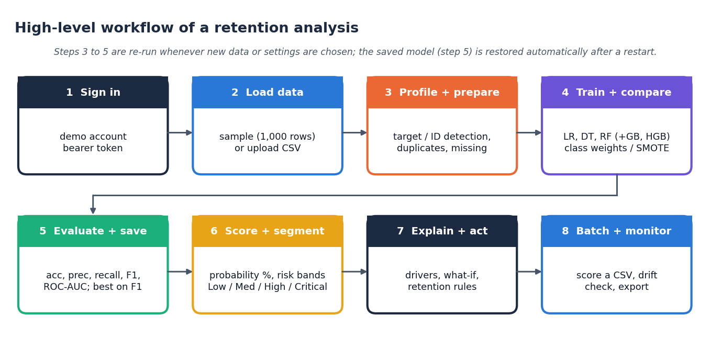
Figure 1: High-level workflow of a retention analysis in ChurnIQ

6.1 Overview of the Methodology
The method is a supervised-learning pipeline wrapped in an explanation and action layer. Thirteen steps run in order; the first eight are executed once per data set (training time), the last five for each customer or batch (scoring time).
1. Load and profile. Read the CSV, detect the target (Churn) and ID (customerID) columns, convert numeric-looking text columns, and report types, missing values and duplicates.
2. Clean. Drop exact duplicate rows; keep missing values for the pipeline to impute.
3. Split. Stratified 80/20 train/test split with random_state 42 (test size selectable from 10% to 40%).
4. Preprocess. Fit a ColumnTransformer on the training split only: median imputation and standardisation for numeric fields, most-frequent imputation and one-hot encoding (unseen categories ignored) for categorical fields.
5. Handle imbalance. Class weights (default), SMOTE on the transformed training split only, or no handling.
6. Train. Logistic Regression, Decision Tree and Random Forest (required); Gradient Boosting and Histogram Gradient Boosting (optional).
7. Evaluate. Accuracy, precision, recall, F1-score, ROC-AUC, confusion matrix, ROC and precision-recall curves on the untouched test split.
8. Select and save. Choose the best model on the selected metric (F1 by default); save the model, preprocessor and metadata to models/.
9. Score. Churn probability = predict_proba x 100 for every customer.
10. Segment. Assign Low, Medium, High or Critical risk from editable thresholds (30 / 60 / 80 by default).
11. Explain. Global importance of features and, for one customer, the drivers that push the score up and down.
12. Recommend. Apply the retention rules to customers at or above 60%.
13. Monitor. Score new files in batch and compare new data with the training data for drift.

6.2 Data Acquisition and Loading
The sample data are produced by generate_sample_churn_data(n_customers=1000, random_state=42). The generator draws the 21 Telco-style fields with realistic proportions (for example 55% month-to-month contracts, 44% fibre-optic, 34% electronic check) and sets churn from a latent logistic risk score: month-to-month contract adds risk, long tenure reduces it, electronic check, fibre optic, missing tech support and online security and higher charges add risk, and Gaussian noise (standard deviation 0.55) is added before the label is drawn. The resulting churn rate is 26.4%. The generator exists so that the application can be demonstrated without a data file; it is not a model of any real operator.
An uploaded file is read with pandas. The target is found by name (churn, target, label, exited, is_churn or churned, in any case) and the identifier by name (customerID, customer_id, id, custid) or, as a fallback, as a text column whose values are all unique. A text column whose name suggests money (TotalCharges, MonthlyCharges, charges, amount) is converted to numbers; blank strings, which occur in the public Telco file, become missing values. The target is normalised to 0/1: the strings yes, 1, true, churned, churn and y (any case) are positive, everything else is negative. validate_dataset_for_training refuses an empty table, a missing target, fewer than 30 rows, a single class or a class with fewer than 5 examples before any model is trained.

6.3 Cleaning, Preprocessing and Splitting
Exact duplicate rows are dropped (none in the sample). The remaining columns are split into numeric (SeniorCitizen, tenure, MonthlyCharges, TotalCharges) and categorical (15 fields). The ColumnTransformer treats them differently because the models need numbers and because categories have no order:
Table 2: Preprocessing of the feature types
Type | Fields | Steps
Numeric | SeniorCitizen, tenure, MonthlyCharges, TotalCharges | Median imputation, then StandardScaler (z = (x - mean) / sd)
Categorical | 15 fields (gender, Partner, ..., PaymentMethod) | Most-frequent imputation, then one-hot encoding with handle_unknown = ignore

After encoding, the 19 raw features become 45 numeric inputs. The preprocessor is fitted on the training split only and applied to the test split, so no test information reaches the models. The split is stratified, so training and test sets keep the churn proportion: with test size 0.20 and seed 42 the sample gives 800 training rows (211 churners) and 200 test rows (53 churners). Unseen categories at scoring time are ignored (all-zero one-hot) instead of raising an error.

6.4 Handling Class Imbalance
Three strategies are offered, and the Train page lets the analyst choose one. Class weights make an error on the rare class cost more: for the Logistic Regression, Decision Tree and Random Forest the weight of a class is n / (2 x n_class). On the training split this is 1.896 for churners and 0.679 for retained customers. Gradient Boosting and Histogram Gradient Boosting in this implementation take no class weight, so this strategy leaves them unchanged. SMOTE [11] creates synthetic churners by interpolating between a minority example and one of its nearest minority neighbours, x_new = x_i + u (x_nn - x_i) with u drawn uniformly from [0, 1]; it is applied to the transformed training split only, never to the test split, and the application falls back to class weights if the imbalanced-learn package is missing. None trains on the data as they are and exists to show the cost of ignoring imbalance (Chapter 8).

6.5 Classification Algorithms
Five learners are registered in MODEL_REGISTRY. Their settings were fixed in advance and are the same in every experiment; no hyper-parameter search was run.
Table 3: Models and their settings
Model | Setting in the code | Why it is included
Logistic Regression | max_iter 2000, L2 penalty (default), random_state 42 | Transparent baseline; coefficients are directly interpretable
Decision Tree | max_depth 8, min_samples_leaf 10, Gini | Rules a business user can read
Random Forest | 300 trees, max_depth 12, min_samples_leaf 5 | Robust ensemble for mixed data
Gradient Boosting (optional) | 200 trees, max_depth 3, learning_rate 0.08 | Sequential boosting
Hist Gradient Boosting (optional) | max_depth 6, learning_rate 0.08 | Fast histogram boosting

Logistic Regression models the log-odds of churn as a linear function of the encoded inputs and turns them into a probability with the logistic function:
P(churn | x) = 1 / (1 + exp(-(b0 + w1 x1 + ... + wp xp))) (1)
Because the inputs are standardised, the size of a coefficient w_j compares features directly, and the product w_j x_j is the contribution of feature j to the log-odds of a given customer; this is the quantity the local explanation uses. A Decision Tree splits the data repeatedly on the feature and threshold that most reduces Gini impurity,
G = 1 - sum over classes k of p_k^2 (2)
and stops at depth 8 or when a leaf would hold fewer than 10 customers. A Random Forest [13] averages the probabilities of 300 such trees, each grown on a bootstrap sample with random feature subsets. Gradient Boosting [20] adds trees one at a time, each fitted to the errors of the ensemble so far, with a shrinkage of 0.08.

6.6 Evaluation Metrics
With TP, FP, TN and FN the counts of the confusion matrix (churn is the positive class):
Accuracy = (TP + TN) / (TP + TN + FP + FN) (3)
Precision = TP / (TP + FP) Recall = TP / (TP + FN) (4)
F1 = 2 x Precision x Recall / (Precision + Recall) (5)
Precision is the share of customers flagged as churners who really leave; recall is the share of real churners that are flagged; F1 is their harmonic mean. ROC-AUC is the probability that a randomly chosen churner is scored higher than a randomly chosen retained customer; 0.5 is chance and 1.0 is perfect ranking. Accuracy is reported but is not used to choose the model, because on 26% churn a classifier that never predicts churn scores 74%.

6.7 Model Selection
select_best_model(results, metric) returns the model with the highest value of the metric chosen on the Train page; the default is F1 and the alternatives are accuracy, precision, recall and ROC-AUC. The Evaluation page shows the comparison table, the confusion matrix of the selected model and the ROC and precision-recall curves of every model, and recommends one. The analyst saves the chosen model, which writes the three joblib files.

6.8 Risk Segmentation
assign_risk_category maps the probability (0-100) to a band using three editable thresholds:
Table 4: Risk bands at the default thresholds
Band | Probability range | Meaning
Low Risk | below 30 | No action beyond normal service
Medium Risk | 30 to below 60 | Watch; general satisfaction check
High Risk | 60 to below 80 | Rules R1-R9 can fire
Critical Risk | 80 and above | Rules R1-R10 can fire; direct conversation

The server rejects thresholds that are not ordered with a minimum gap (Low between 5 and 50, Medium at least 5 points above Low and at most 85, High at least 5 points above Medium and at most 95), so the four bands always exist. On the sample, the saved Logistic Regression model places 253, 481, 213 and 53 customers in the four bands. Because class weights raise the scores of all customers (mean score 45.9% against 26.4% real churn), the bands are best read as a ranking of customers and not as chances of leaving.
The decisions of the pipeline are summarised in the flowchart below; every box corresponds to a function in src/.
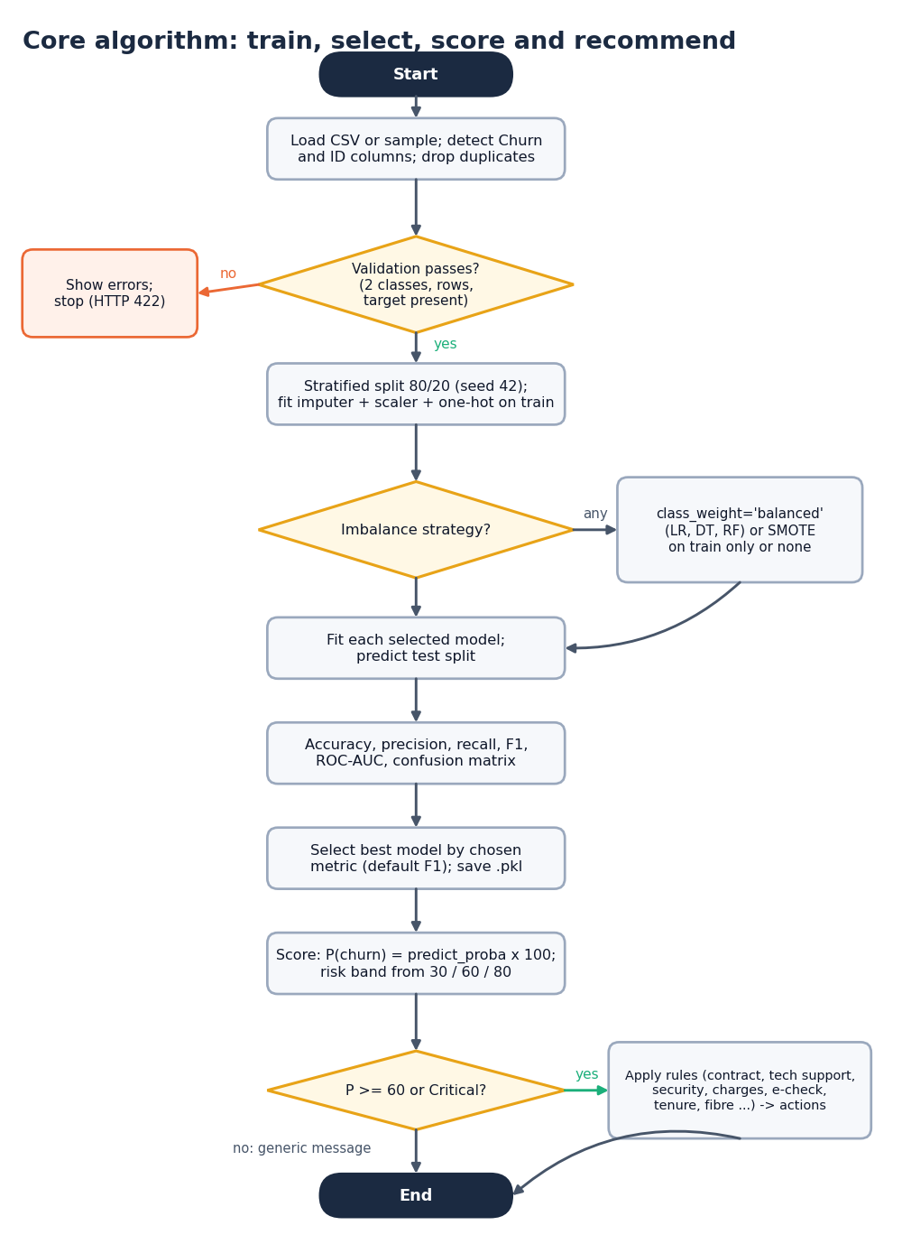
Figure 2: Flowchart of the core algorithm: train, select, score and recommend

2. NOVELTY AGAINST THE BASE PAPER
This section sets the project against the base paper [1] and separates what is new from what is standard. The project is an applied extension of the paper's motivation, not a reproduction of its experiments.
Table 5: Novelty compared with the base paper
Element | Base paper | This project | Status
Prediction models | Seven classifiers incl. CatBoost, XGBoost, LightGBM | LR, DT, RF + GB, HGB from scikit-learn | Standard; no new learner
Imbalance | Class weights, scale_pos_weight | Class weights, SMOTE on the training split only, none; recall measured with and without | Standard methods, compared explicitly
Model selection | Recall as the objective | Any of accuracy, precision, recall, F1, ROC-AUC; F1 by default | Small variation
Explanation method | Unified perturbation explainer (RNP, FA, IM, AP), SHAP, LIME | Coefficient x value (local), built-in and permutation importance (global); SHAP optional | Simpler and cheaper; not a new explainer; no unified explainer implemented
From score to action | Business recommendations in the discussion | Ten transparent IF/THEN rules with reasons, gated at 60% | New in this project (heuristic, effect unmeasured)
Per-customer view | Global importance | Customer 360: profile, score, band, drivers, actions | New in this project
Scenario analysis | Not present | What-if re-scoring of an edited customer | New in this project
Operations | CRM integration proposed | Batch scoring with schema check, drift screening, saved-model restore, API and web interface | New in this project (single-user)
Evaluation honesty | Single split on real data | Cross-validation, repeated splits, environment sensitivity, calibration and lift measured and reported | Good practice applied; reported openly

The novelty is therefore in the combination and the application: a complete, inspectable path from a customer table to a retention action, with the evaluation limits stated. There is no claim of a new algorithm and no claim of better prediction than the base paper.

3. KEY CONTRIBUTIONS
The project makes six contributions.
1. An end-to-end, explainable churn workflow. One tested code path from CSV to risk bands, drivers and retention actions, usable through a Streamlit application and a React web interface (31 API routes, 13 working pages).
2. An evaluation that does not hide its uncertainty. Besides the headline split, results are reported by 5-fold cross-validation and five random splits, under three imbalance strategies and two software environments, with calibration, threshold and targeting analyses.
3. A reproducible experiment record. scripts/run_experiments.py, make_figures.py and measure_api_latency.py regenerate every number and figure in the documents from the project's own code.
4. A transparent retention engine. Ten named rules plus two fallbacks, each returning a reason with its suggestion, so every action can be audited and changed.
5. A tested core. 44 unit tests and a 63-check end-to-end API test; the tests found and fixed a real compatibility defect (pandas 3 string dtype) in the data loader.
6. An honest comparison with the base paper. The differences in data, split, models and goals are stated, with no claim to match or beat its metrics.

